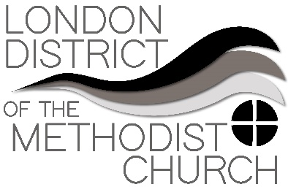
Sharing Best Practice – A Forum
Forum Three: Day to day ministry and obstacles raised by the lockdown
In our third Best Practice zoom call we discussed our day to day ministry and the obstacles raised by the lockdown. How do we care practically for our congregations and members while also not forgetting to look after our own wellbeing and spiritual practice?

Inevitably many of us are finding this emotionally draining and at times depressing, trying tom offer pastoral care to our congregations and communities. And this was an opportunity to share ideas of best practice in these circumstances and offer support to one another.

Some practical issue and ideas emerged including moving some of our groups to online forums – including young adults and bible studies. However in some areas there is real digital poverty which makes this online activity impossible.

People spoke of resisting the ‘need to be needed’, often a natural instinct in minsters (and others), and the need to be kind to oneself and not compare to what others are posting online about how much they are doing and how successful they are being. Love and care of self is very important, giving yourself space and time and more realistic expectations.

Informal church WhatsApp groups had raised some issues when inappropriate content was shared which does not reflect Methodist polices or practices.

The URC has published a booklet 'Ready for the new "normal": A discussion paper for a pandemic recovery and resumption plan', which will help to carry us past the lockdown and into a healthy future.
​
Other useful links and materials:
Resources to support mental health and well-being, April 2020

