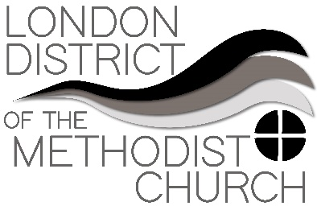
Sharing Best Practice – A Forum
Forum Four: Property
There were many questions raised in this forum, the vast majority of which were addressed by Kathleen Henriques-Brown (District Property Development Officer).
Much of the information needed in regards to property is available on the Methodist Church website pages related to COVID-19 and Property. If your situation is unique and you are not able to locate the answer there then please contact Kathleen Henriques-Brown or the Property Team at the Methodist Church in Britain.
If you need support in convincing lettees, tenants or church members about your church needing to abide with the guidance, then please contact the relevant Chair of District.

