Privacy Notices
For every person you hold a record on, please ensure you are issuing Privacy Notices. This not only ensures we are compliant with our policy, but it is also a legal requirement under Data Protection and GDPR!
You can find the forms
HERE!

Did you know the
Safeguarding Newsletter

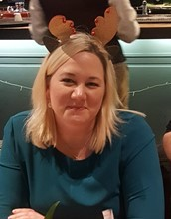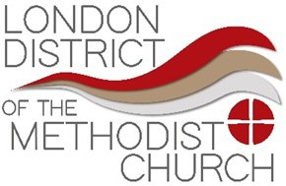December 2019
Wishing you all a very Merry Christmas and a happy new year

elcome to the first edition of the Safeguarding Newsletter, where we bring you all the safeguarding news and updates.
W

District Safeguarding Conference
The 2020 conference titled ‘Through the Looking Glass’ and will be looking at ‘Professional Curiosity & Disguised Compliance’.
We are very excited to announce our keynote
speaker is Marcus Erooga!! Get your ticket here.

Safeguarding Policy has been updated? Check it out HERE!

p.40 of the Practice Guidance for DBS checks discusses portability Check
it out HERE!

Recording Person-centred Accurate
Real Timely
No jargon
Evidence-based
Read the previous record
Succint
Holisitic IT compliant Professional

WHO? WHAT? HOW? WHERE? WHEN?

Audits
We have now begun the audit process. There will be an expectation for Circuits to complete a Self- Audit Tool annually. This will highlight strengths and areas to improve. There will also be a full audit completed every 4 years by the District. This will produce a qualitative thematic report with key actions to be undertaken. Please contact Becky
District Website
The District Website is continually being updated.
We would love this to become a useful source of information for you all. If
there is anything you would like to see please let the District Office know.
Check it out HERE!
Skinner to find out more or to book your full audit.

Circuit Safeguarding Meetings
Having gotten to know some of our circuits over the last 9 months, I have seen some brilliant practices. One of which is the use of Circuit Safeguarding Meetings. These are regular meetings for all your church and circuit safeguarding officers to get together, share any concerns or issues that arise, share ideas, good practices. The feedback from these meetings have been entirely positive and our church safeguarding officers feel they have a supportive network. It would be great to see this across all our circuits.

Safeguarding Forum
Closely linked to the above, we will now hold two forums per year at Central Hall. This will be similar to Circuit Safeguarding Meetings; a supportive network for all our safeguarding officers, each meeting will have a theme with informal training in specialist topic areas. Let us know what you’d like to see!
Becky Skinner District Safeguarding Officer
Tel: 07960 877 740
Email:
safeguarding@
methodistlondon.org.
uk

Diary Dates
16/01/20 Advanced Safeguarding Training at Central Hall

01/02/20 Advanced Safeguarding Training at Lambeth

08/02/20 Advanced Safeguarding Training at Ealing

07/03/20 Advanced Safeguarding Training at Kingston

14/03/20 District Safeguarding Conference at Central Hall

28/03/20 Advanced Safeguarding Training at Barking, Dagenham &
Ilford

DISTRICT SAFEGUARDING CONFERENCE | 14TH MARCH 2020
Through the Looking Glass | Professional Curiosity & Disguised Compliance

