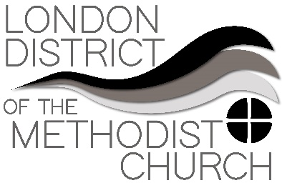
Sharing Best Practice – A Forum
Forum Two – Worship in the Lockdown

Our second “best practice” Zoom, conference took place on Wednesday 6th May and revealed that there is lots of excellent work being done around the London District in relation to worship provision during the lockdown. The News reported that something like 25% of the country had turned to online service in recent weeks. Clearly this situation, while tragic and tough for many is proving a valuable opportunity to increase the reach of our worship.
​
One encouraging quote, reflecting on the way that more people are tuning in to online worship than normally attend:

“Lockdown really expanded our church walls!”

Some of key issues we discussed around best practice were:
​
- The importance to check re licensing arrangements if music is being used especially from You Tube. This website might be useful https://www.rscm.org.uk/live-streaming-of-church-services/ Methodist Central Hall Westminster is well down this road and Tony Miles would be happy to help with any queries in this area.
- Keeping worship feeling “live” rather than a “performance” was a challenge to some – keeping a sense of the joy of being together – so hard to replicate remotely.
- Worship does not need to be an hour long (or longer). Short messages with impact (remember, people are one click away from leaving!!). People find it difficult to focus on Zoom or YouTube for too long.
- It’s not necessary to replicate every aspect of Sunday worship – many services are including no more than two songs/hymns (if any). Using a backing track (recorded on piano) and posting words so people can join in singing is one approach. Trying to get everyone singing on a Zoom call doesn’t work because of the delays.
- Some suggested open mic zoom chats before or after services which were being streamed live - to have that sense of informality and “chatting over coffee”
- Many reported large increases in the numbers of people worshipping together. In some cases online congregations had doubled or more, often reaching beyond church members who attended infrequently to people with no connection with the church.
- One problem was reaching out to those not confident with technology, or without access to smart phones and computers. Printed materials can be used but are not always helpful to some. It was pointed out that it is also possible to phone in from a regular phone to zoom calls.
- Using this technology also means that worship can happen all through the week with several ministers offering daily prayers and setting up phone prayers that people can ring into for free.
Check out the Methodist Church ‘Dial a Prayer’ resources:
https://www.methodist.org.uk/about-us/coronavirus/prayers-during-the-coronavirus-pandemic/dial-a-prayer/
- Thoughts about the foreground and backdrop to worship setting were shared. One church had used blockposters.com to create a backdrop of their church sanctuary which looked effective on screen. Think about what is behind you and the placement of the camera. Try to have the camera higher than the person speaking (avoids too many nostril shots!). Can images of candles or a cross be used during recorded prayers? Can some of the service be recorded in a garden or in a park during daily exercise – moving away from all being led from one room?
- Consider sending orders of service to local care homes, particularly ones with which you already have a relationship.

Some other useful resources:
- If your church is new to the technologies required for online worship https://www.computersforcharities.org/ might be able to help get you started
- https://theworshipcloud.com/ for free weekly resources and also a subscription service for a wider range of worship materials. This is high quality content with an emphasis on images and is a Methodist project.
- Daily reflections in the Ignation tradition: https://pray-as-you-go.org/
- Singing the Faith plus has resources for worship during lockdown and ideas about online worship.

