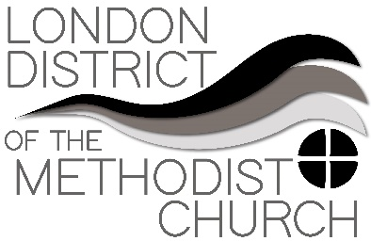
Sharing Best Practice – A Forum
Forum Seven: 'What might ministry and mission look like in the community post-lockdown?’

To consider the set question, another question ought to be considered before we can take things any further. That is: Will there be a difference between Mission and Ministry? If we are trying to get to grips with how things might look in the coming weeks and months, we need look back and remind ourselves where we were prior to lockdown.
​
In a nutshell, Ministry was usually understood to be about the demands of internalized church. Whereas Mission was more about how to externalize church. The lines were blurred, allowing for all sorts of expressions of church to make claims of being the way ahead. Such expressions, had either a familiar recruiting flavour - as attractional models; or had the less palatable taste of prioritizing being incarnational within community.
​
If anything, the lockdown has brought the two together, in an alliance that says: Guess what? Congregations can no longer simply look at communities as recruiting grounds. Nor can the more fluid form of discipleship look at community as a place for well-meaning Christian excursions.
​
The reason is that the future holds up its sign: Beware, new and unknown horizons.
​
In any understanding and however we might suggest post lockdown Mission and Ministry will look like; they will probably need to become completely intertwined to be effective. The main reason is that we have lost a high level of internalization and we have lost opportunity to externalize that which we radicals think are the answers to the church’s problems. I sense that the future mix of ministry, mission, and community, places us in a newly shaped dynamic. One that calls us to be active in God’s Mission to a new post lockdown community in which we are all included. Or, as I was reminded of yesterday, mission and ministry might now have to sail together toward ‘remnant islands’, including our own, and responding to need. Not portraying ourselves as the answer but offering ourselves as God’s love in action; in that, we must learn how things evolve because of that experience. Meaning that mission and ministry, in post lockdown, might require the church be more of guests in context, instead of being the host. To qualify that the integrity of the Body of Christ, is the priority of the other and their need.
​
A final comment:
​
As we move out of lockdown towards being a physically gathered church again, a Trinity of questions might be the lens we need in order to adapt our vision as we respond to the to the changes that have been thrust in our direction. We have a great opportunity over the coming weeks to intentionally ask: What questions has this time of lockdown raised for us going forward? What is God saying to us? How best are we able to respond?
​
Blessings to one and all,
David.

